1: **use vi to update the text file created in the previous assignment   
search and replace "Nepal" with your name**

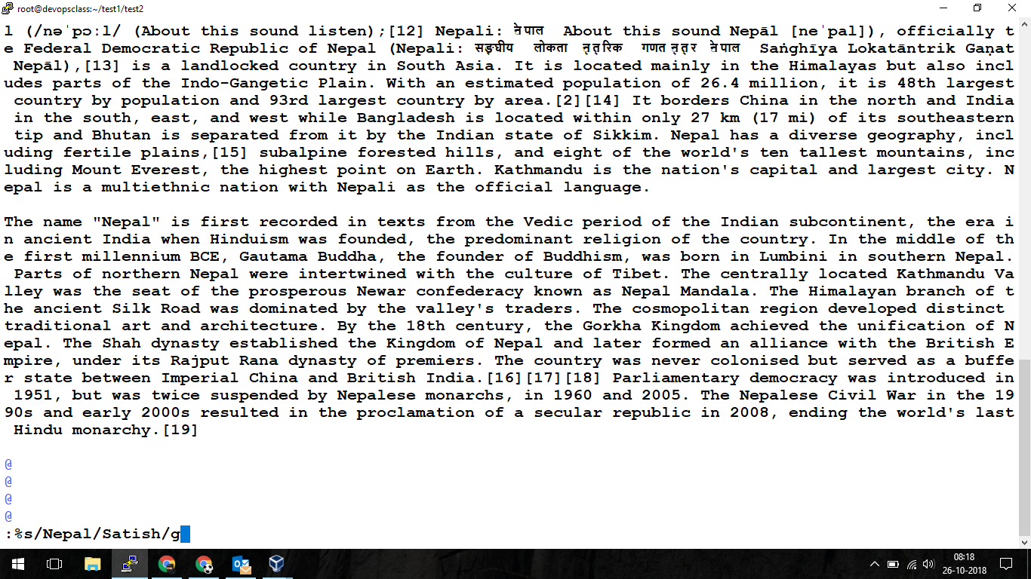

**Using cat command to read Nepal.txt**

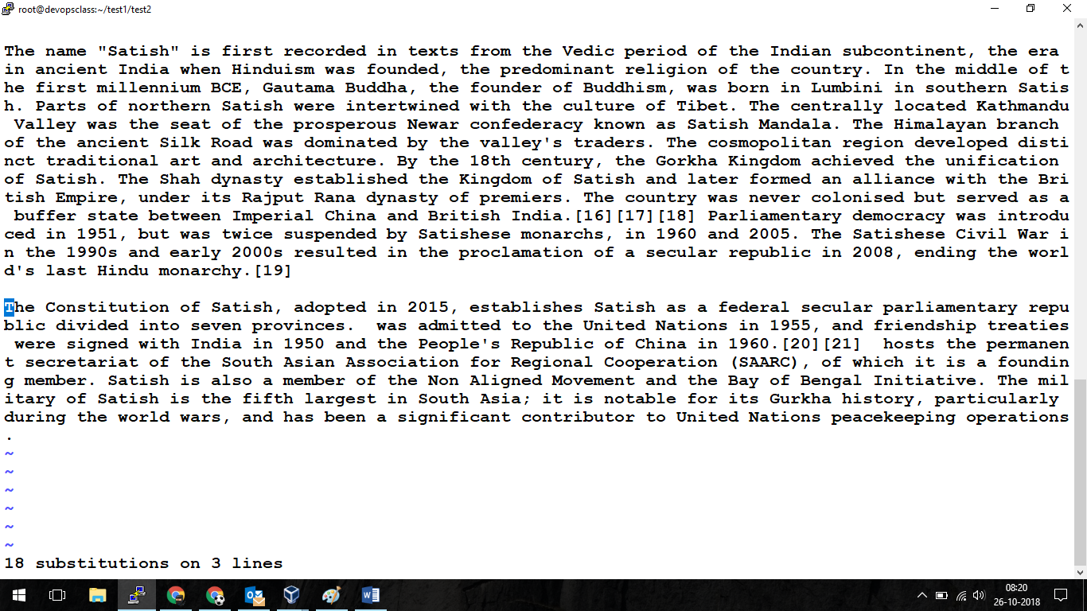

2. Using Linux commands

**Locate –**

yum install mlocate -y

updated

locate nepal.txt

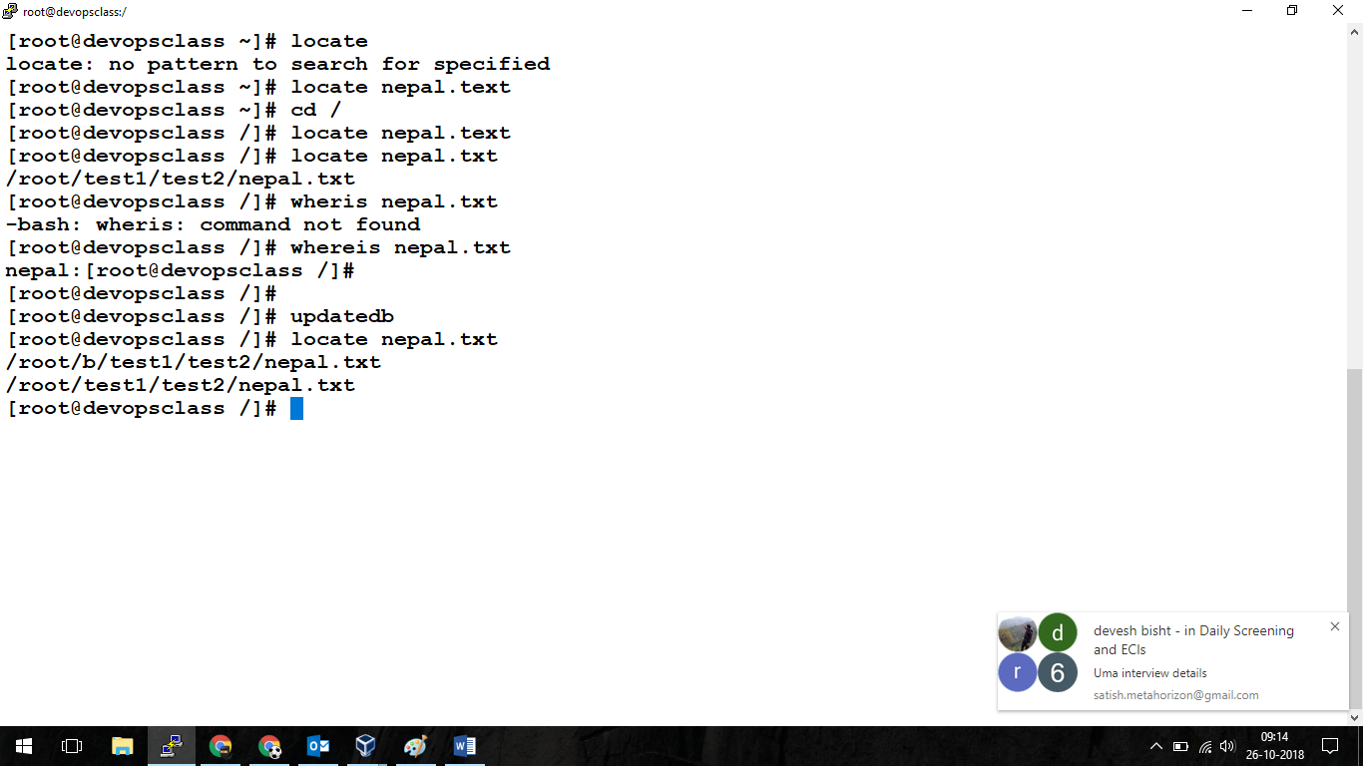

**zip –**

**yum install zip unzip -y**

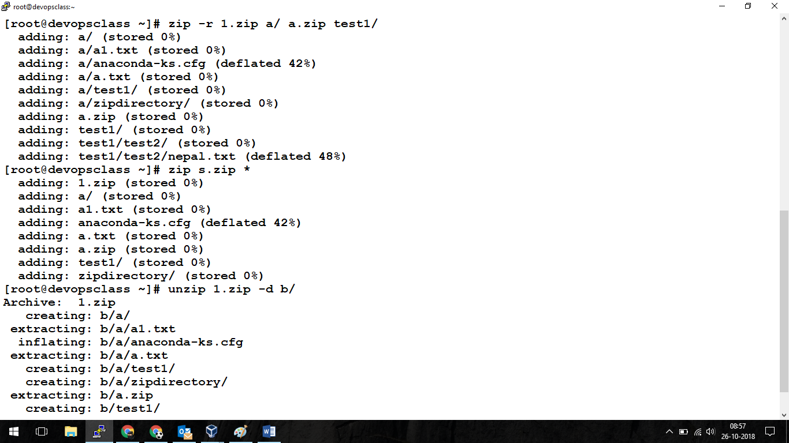

Using **less** command to read file

Less /root/test1/test2/nepal.txt

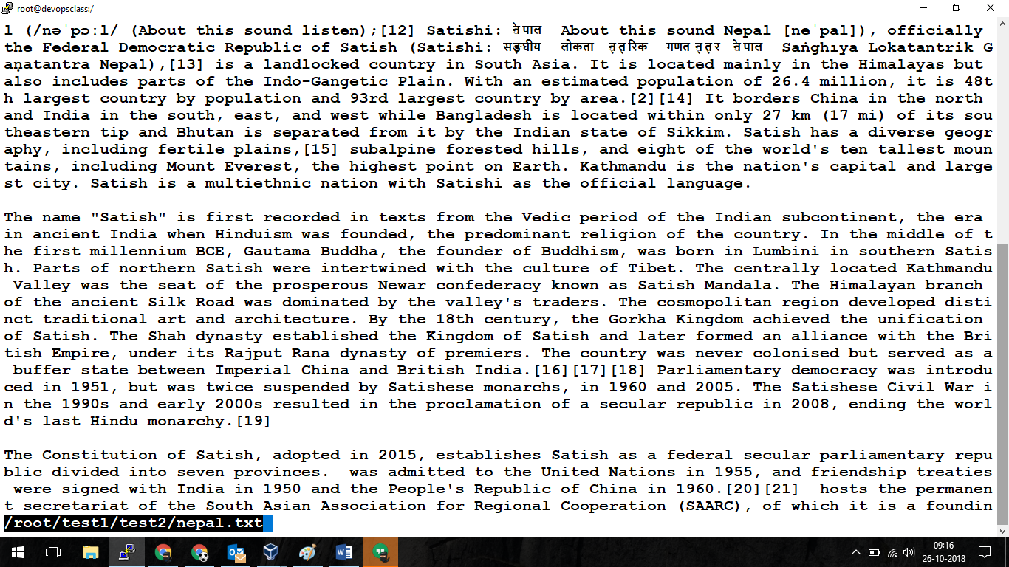

Using vimdiff : **vimdiff nepal.txt nepal2.txt**

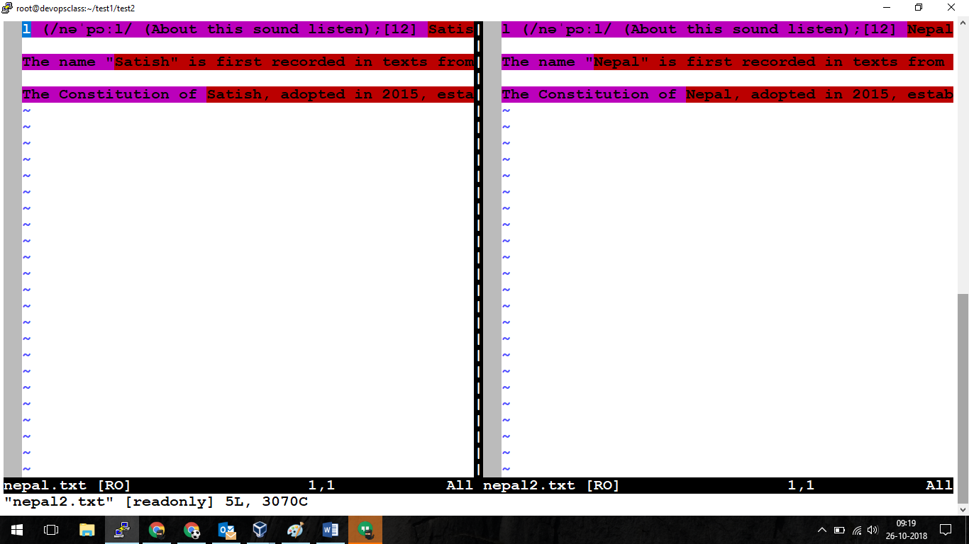

Using **Grep** command with **netstat**

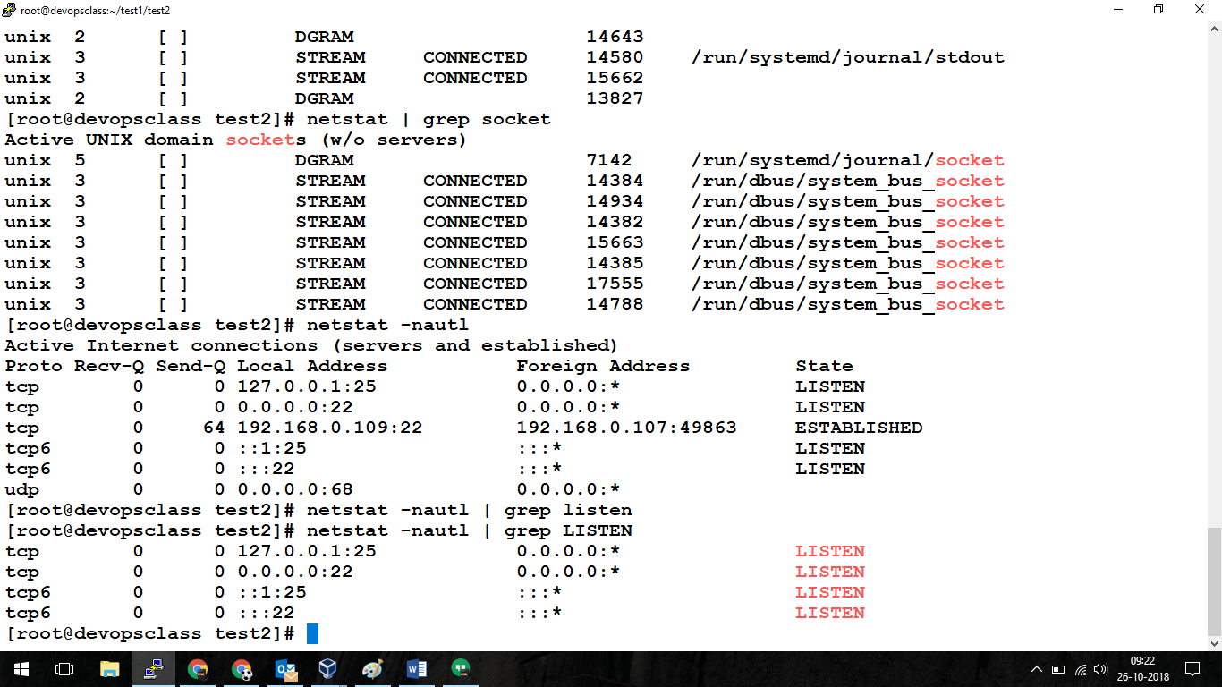

Using df command:

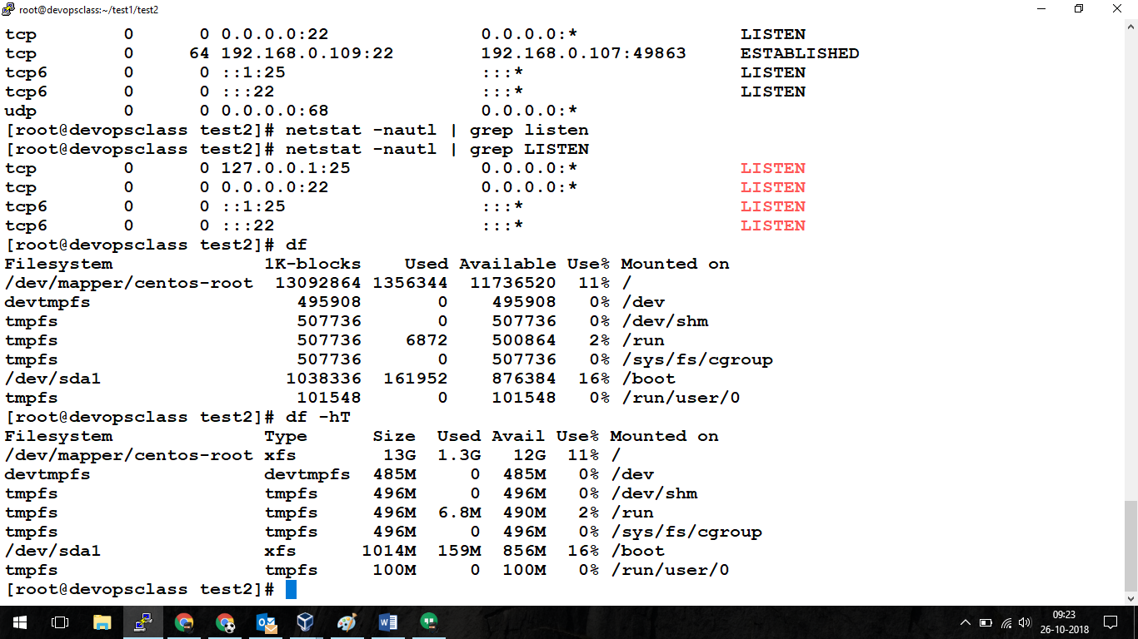

Using du command

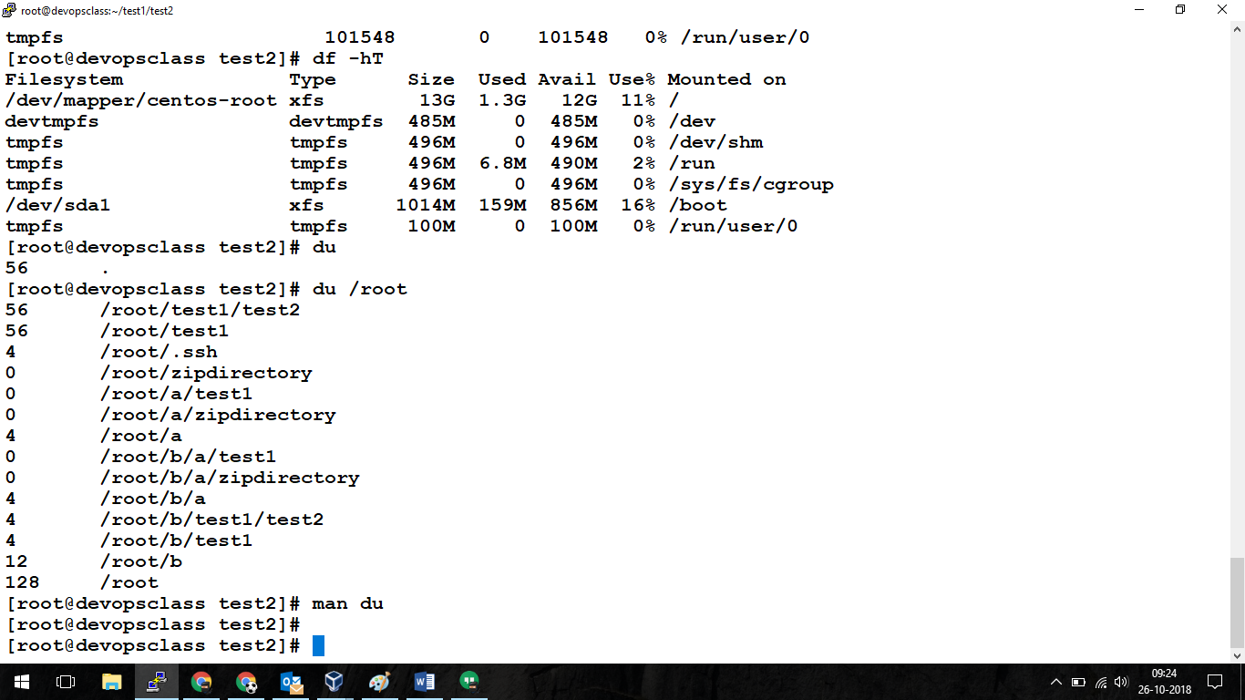

Using free,date & ulimit command

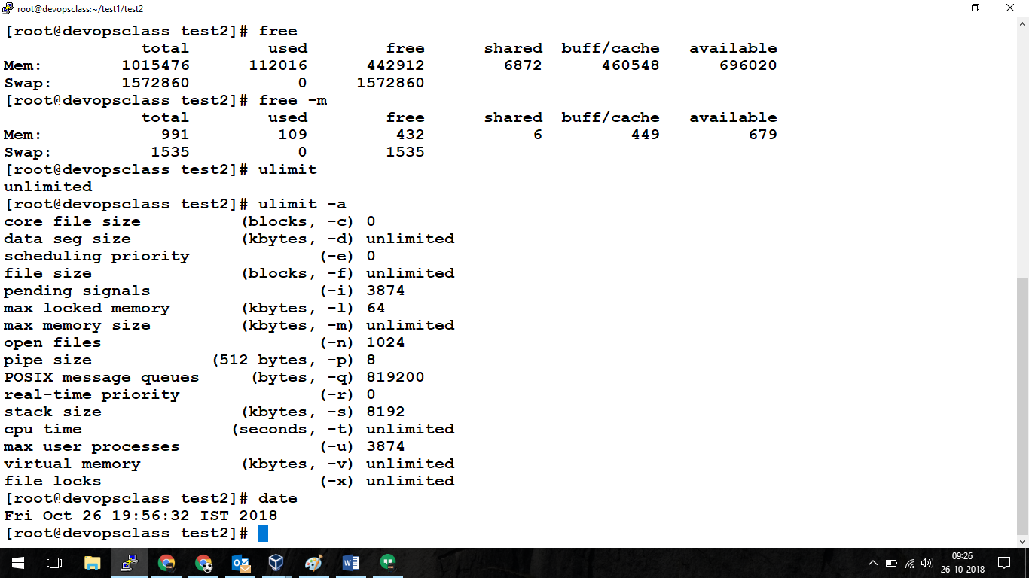

Practicing nestat

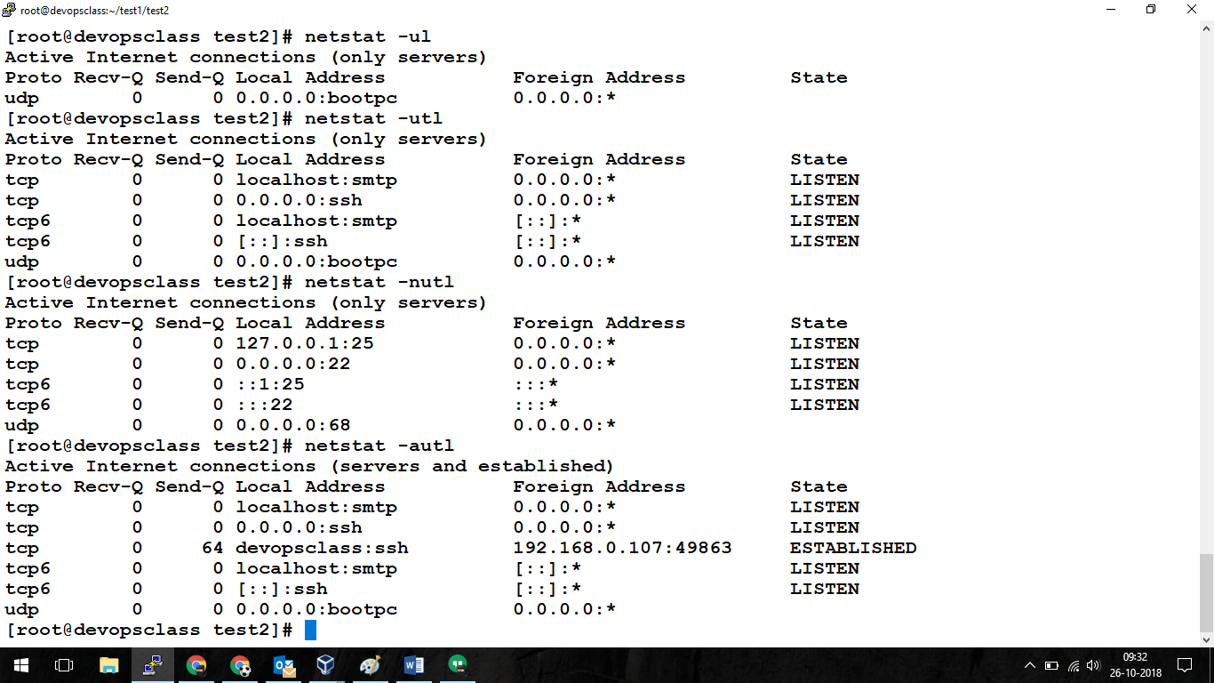

Practicing ps commands

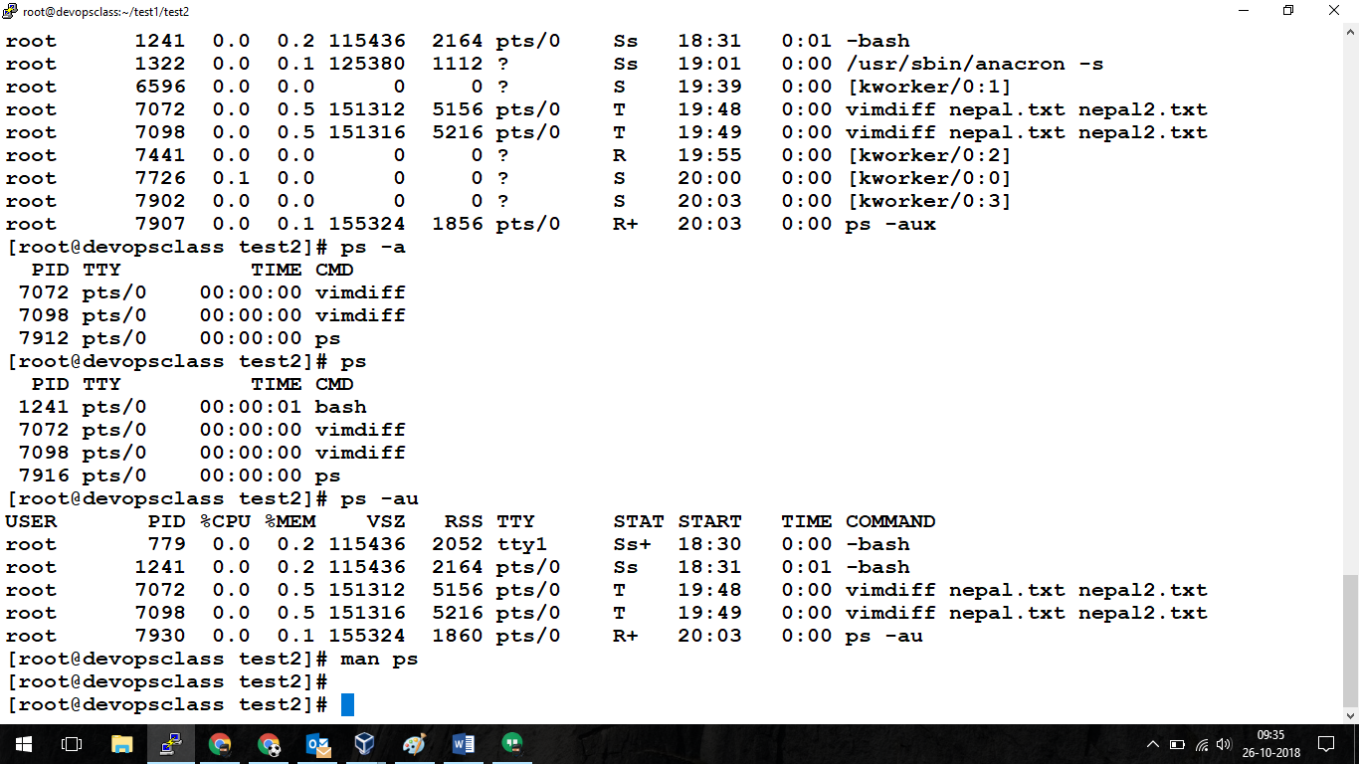

Using top

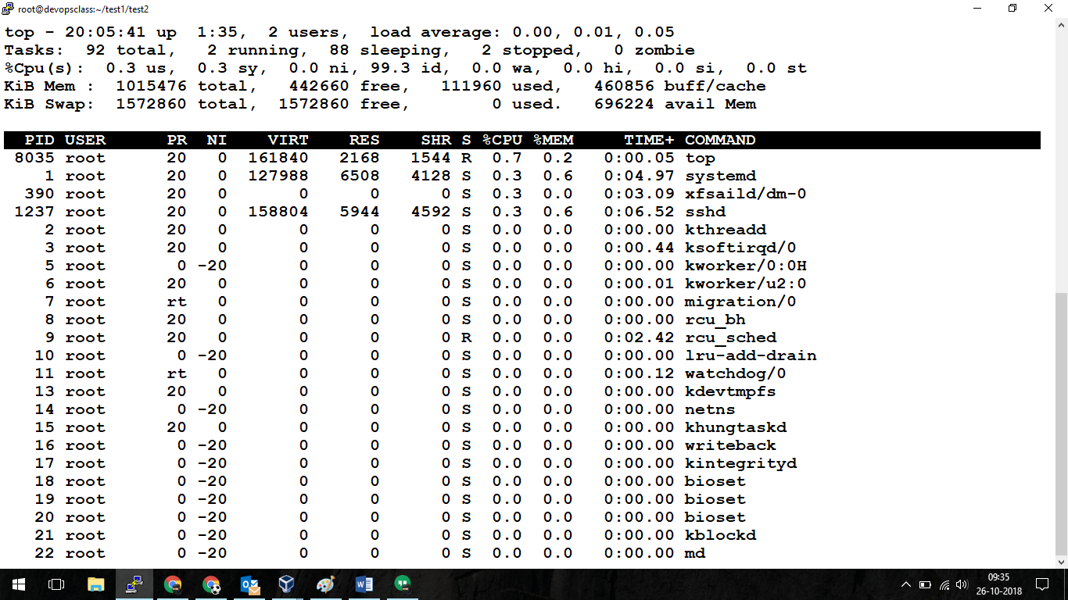

Kill command:

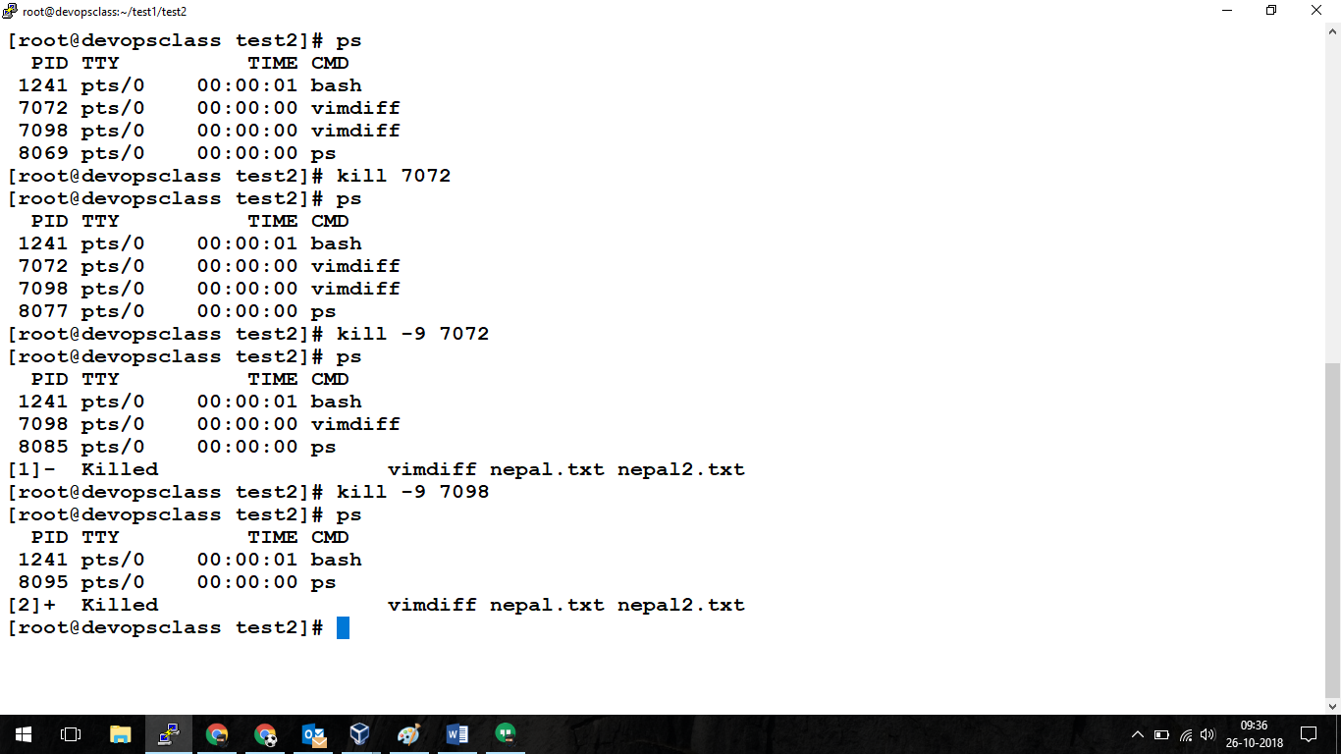

Usinge Ping & telnet

